Rodrigo Brasil 10/2023

### **Part 1: GPO Creation**

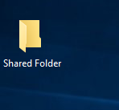

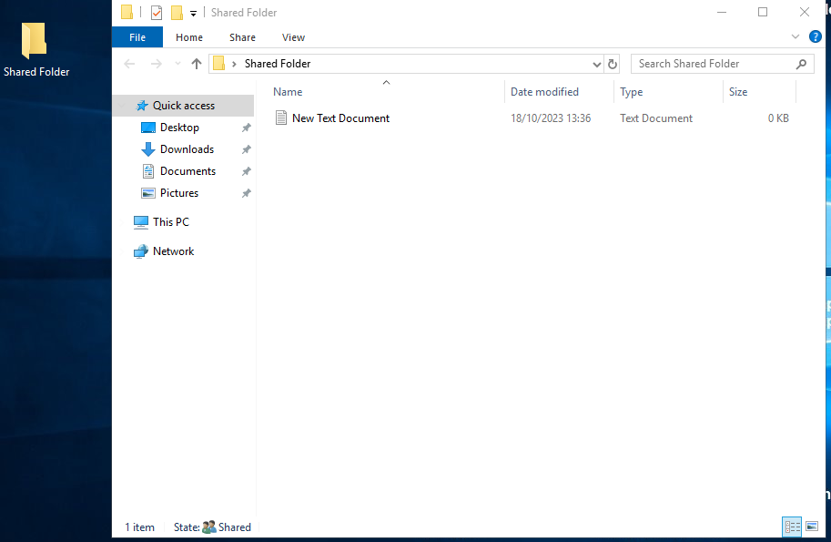

Created a shared folder on the win server 2019

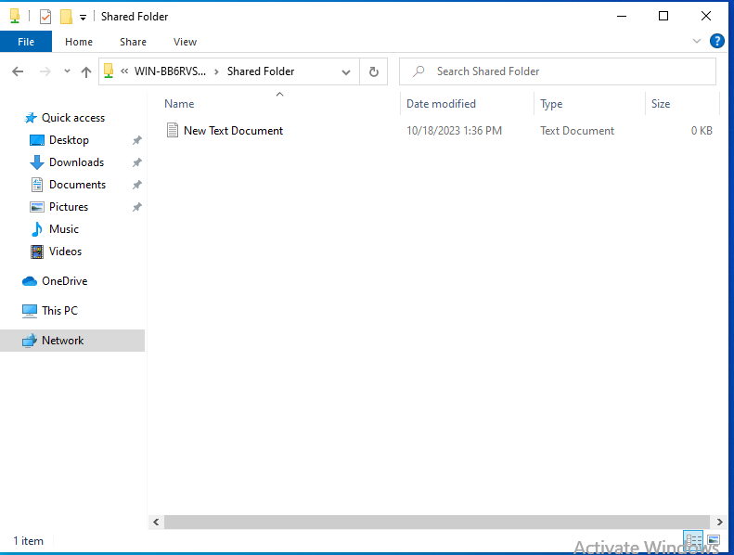

Shared folder being accessed on the win10 VM



New user created

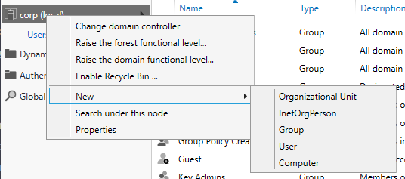

Creating a Organizational Unit (OU)



OU Created

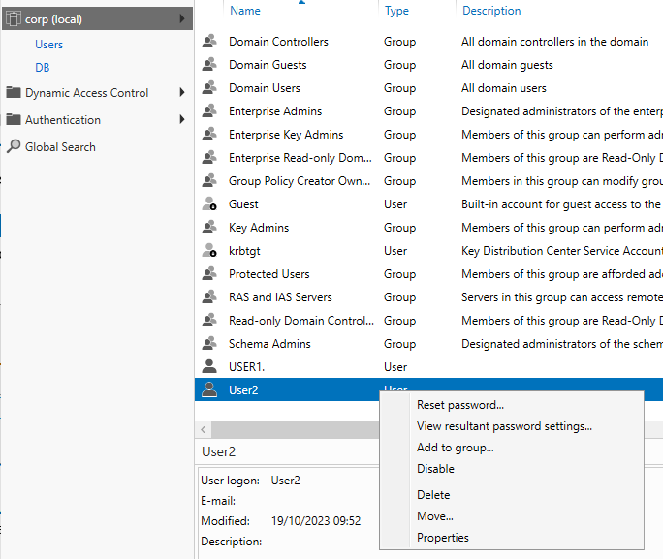

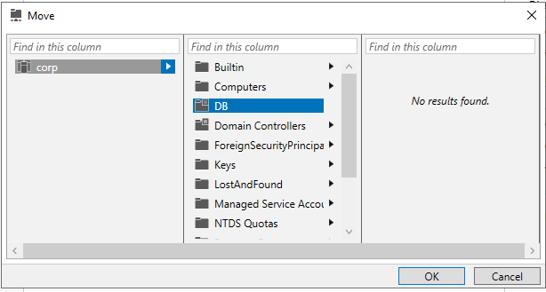

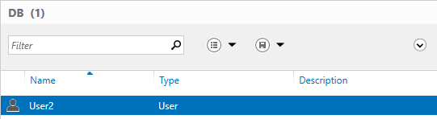

Moving the created user to the OU

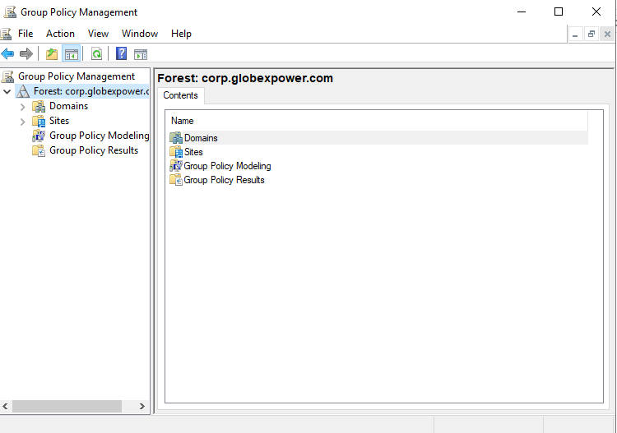

Open the Group Policy Management

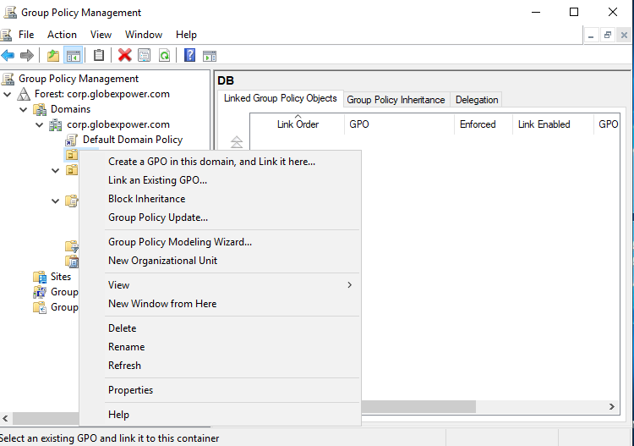

Right click the previously created OU and click “Create a GPO (Group Policy Object) in this domain, and link it here..”

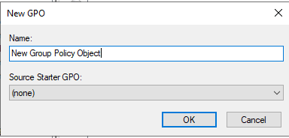

Give it a name, we will call it “Pictures Folder Redirection”

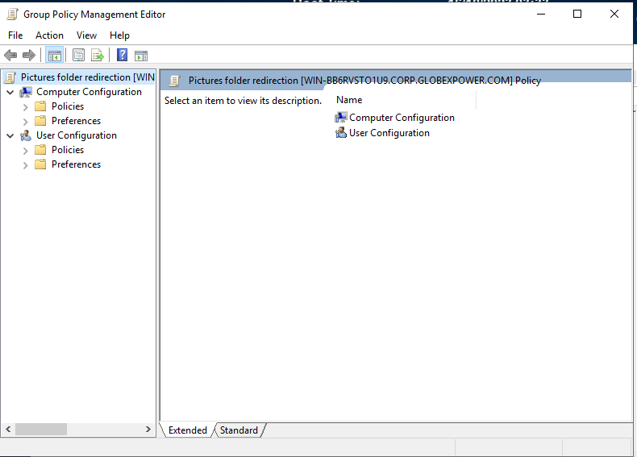

Right click the newly created GPO and click edit to open the GPO management editor

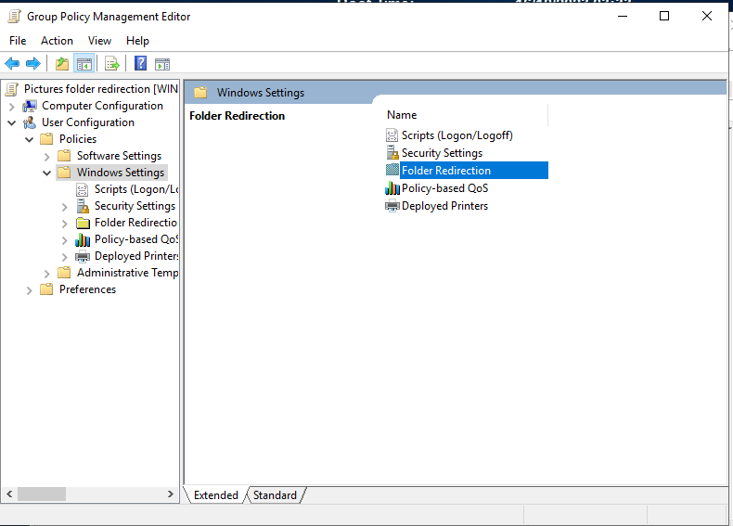

Select “User configuration, Windows settings, Folder redirection”

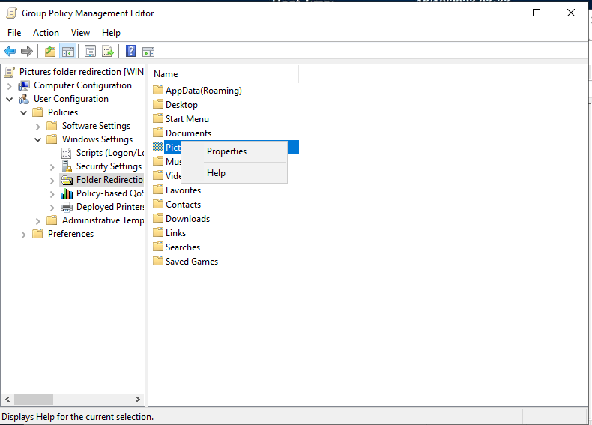

Right click the pictures folder and select properties

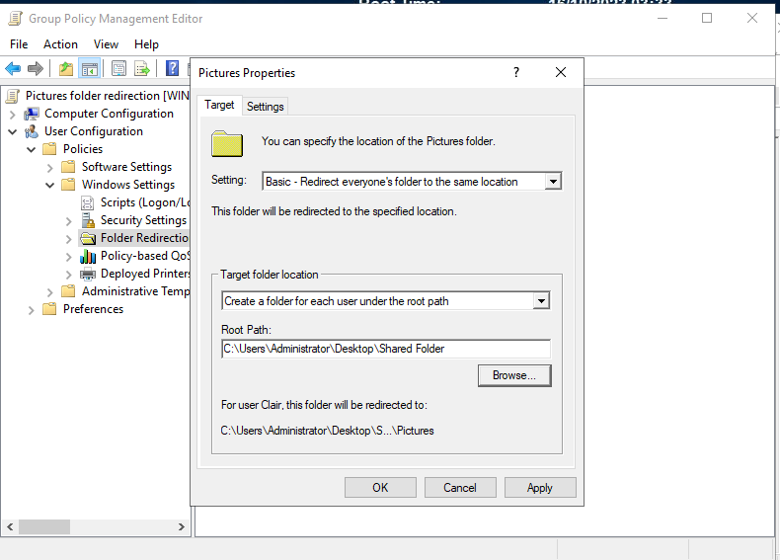

In the settings select the basic option, in the target folder location select “create a folder to each user under the root path” and on root path select the path to the previously created shared folder

After doing so apply and do the same again but change the target folder location to “” and apply

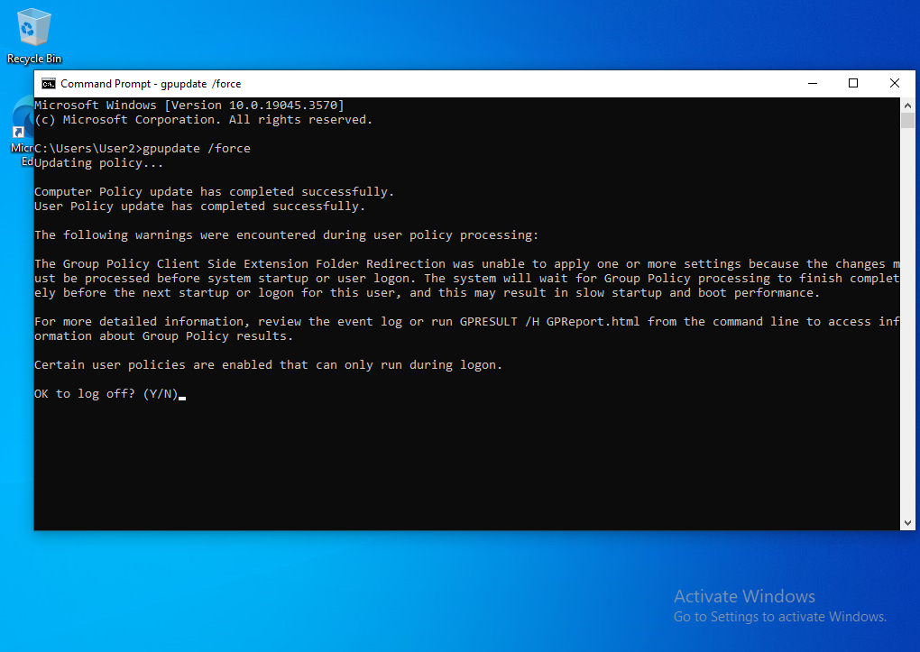

On the user computer run cmd and type the command “gpupdate /force” to update the policies on the user